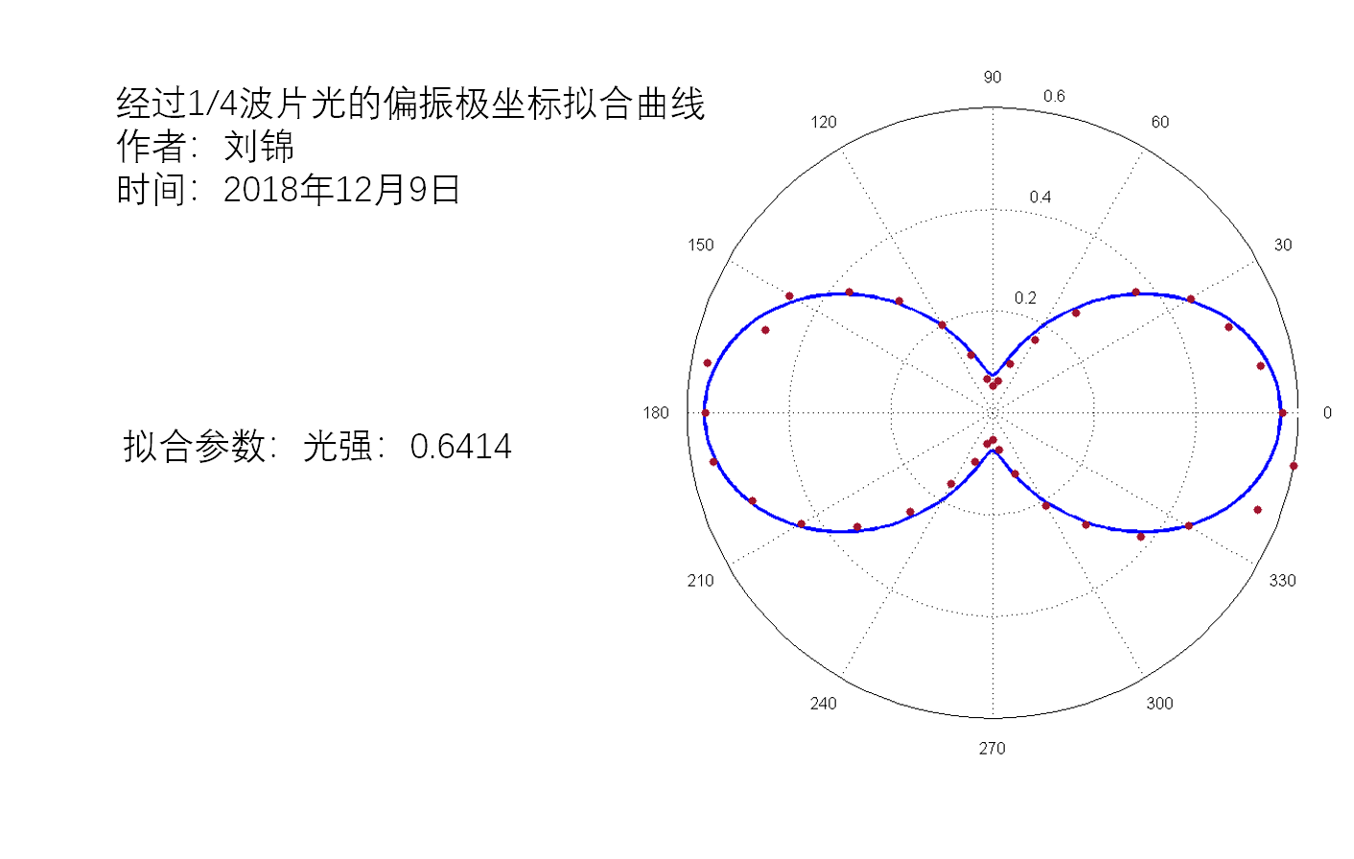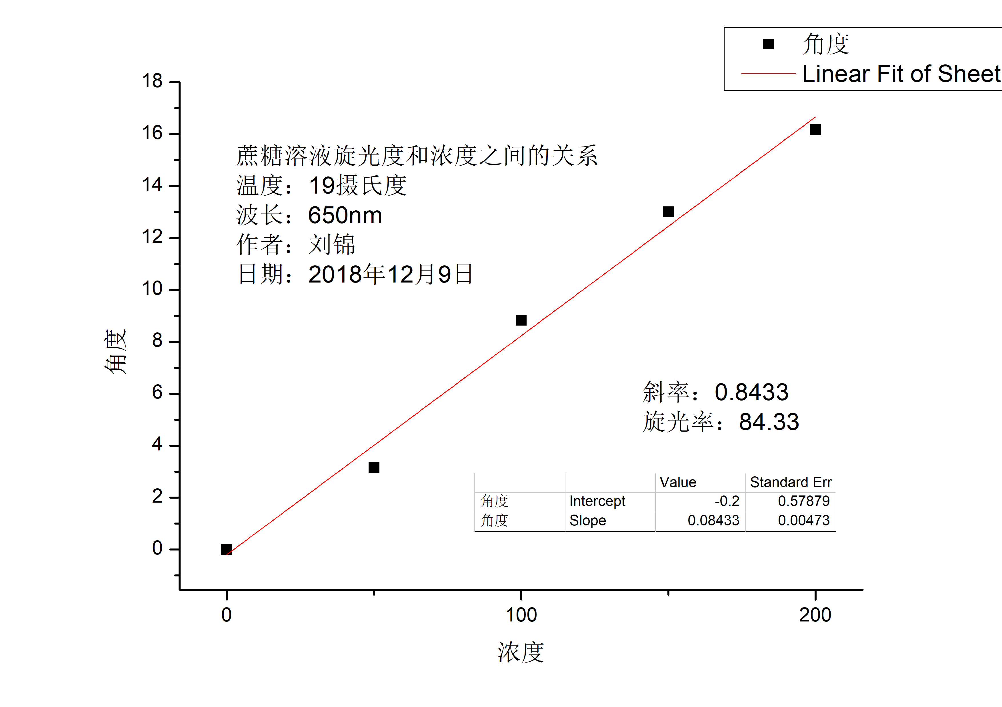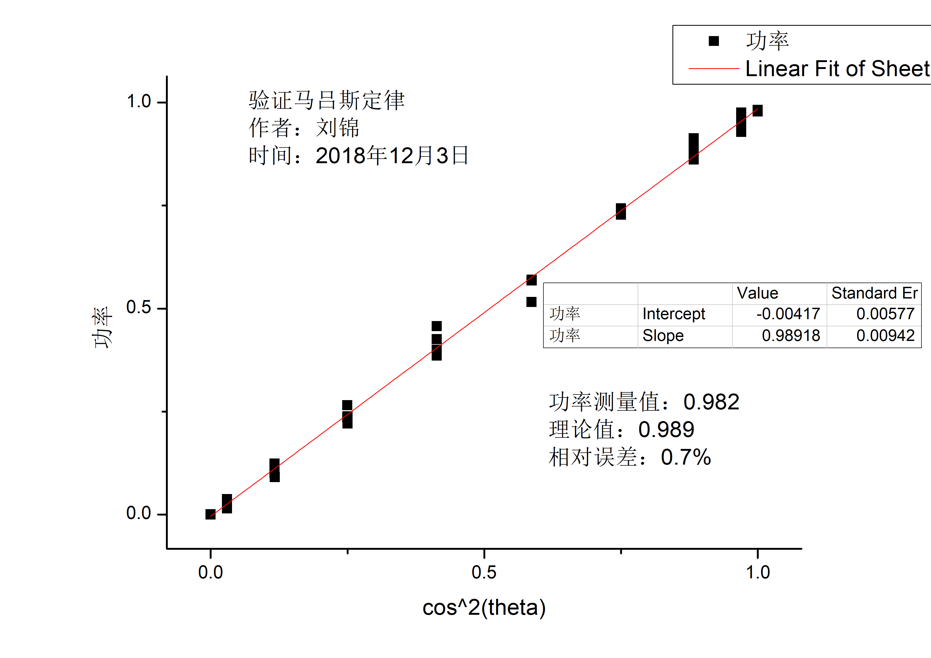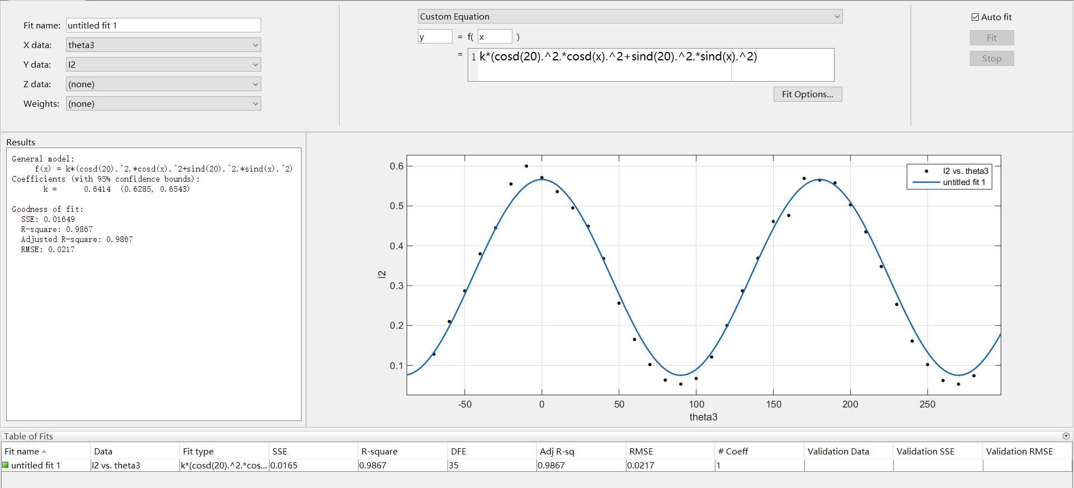

|  |  |  |  |  |  |
| --- | --- | --- | --- | --- | --- |
| 马吕斯定律 | |  |  | 四分之一波片 | |
| 角度 | 功率 | 修正角度 | cos^2(theta) | 波片转20度 | 转45度 |
| 0 | 0.734 | -30 | 0.750013373 | 0.1282 | 0.247 |
| 10 | 0.913 | -20 | 0.883028839 | 0.21 | 0.316 |
| 20 | 0.929 | -10 | 0.969848071 | 0.287 | 0.342 |
| 30 | 0.982 | 0 | 1 | 0.38 | 0.415 |
| 40 | 0.976 | 10 | 0.969848071 | 0.445 | 0.454 |
| 50 | 0.892 | 20 | 0.883028839 | 0.555 | 0.516 |
| 60 | 0.728 | 30 | 0.750013373 | 0.6 | 0.535 |
| 70 | 0.568 | 40 | 0.586844366 | 0.571 | 0.482 |
| 80 | 0.426 | 50 | 0.413201257 | 0.536 | 0.42 |
| 90 | 0.238 | 60 | 0.250026747 | 0.495 | 0.385 |
| 100 | 0.1 | 70 | 0.11700094 | 0.449 | 0.357 |
| 110 | 0.0274 | 80 | 0.030167775 | 0.368 | 0.298 |
| 120 | 0.0006 | 90 | 2.14617E-09 | 0.256 | 0.228 |
| 130 | 0.037 | 100 | 0.030136087 | 0.165 | 0.185 |
| 140 | 0.1239 | 110 | 0.116941385 | 0.102 | 0.157 |
| 150 | 0.236 | 120 | 0.249946508 | 0.063 | 0.155 |
| 160 | 0.386 | 130 | 0.413110012 | 0.053 | 0.162 |
| 170 | 0.516 | 140 | 0.586753119 | 0.067 | 0.197 |
| 180 | 0.743 | 150 | 0.74993313 | 0.121 | 0.255 |
| 190 | 0.881 | 160 | 0.882969277 | 0.2 | 0.319 |
| 200 | 0.954 | 170 | 0.969816374 | 0.287 | 0.377 |
| 210 | 0.978 | 180 | 0.999999991 | 0.369 | 0.416 |
| 220 | 0.951 | 190 | 0.969879751 | 0.461 | 0.469 |
| 230 | 0.862 | 200 | 0.883088387 | 0.476 | 0.463 |
| 240 | 0.732 | 210 | 0.750093608 | 0.569 | 0.498 |
| 250 | 0.57 | 220 | 0.586935609 | 0.565 | 0.471 |
| 260 | 0.4 | 230 | 0.413292506 | 0.558 | 0.474 |
| 270 | 0.221 | 240 | 0.250106995 | 0.503 | 0.412 |
| 280 | 0.091 | 250 | 0.117060509 | 0.435 | 0.329 |
| 290 | 0.015 | 260 | 0.03019948 | 0.348 | 0.287 |
| 300 | 0 | 270 | 1.93155E-08 | 0.253 | 0.229 |
| 310 | 0.032 | 280 | 0.030104415 | 0.161 | 0.186 |
| 320 | 0.122 | 290 | 0.116881843 | 0.102 | 0.154 |
| 330 | 0.265 | 300 | 0.249866278 | 0.062 | 0.146 |
| 340 | 0.457 | 310 | 0.41301877 | 0.053 | 0.166 |
| 350 | 0.568 | 320 | 0.586661869 | 0.074 | 0.204 |
|  |  |  |  | 0.6 |  |

|  |  |  |  |
| --- | --- | --- | --- |
| 二分之一波片 | |  |  |
| 转15度 |  | 检偏器 | 31 |
| 30 |  |  | 61 |

|  |  |  |  |  |  |  |  |  |
| --- | --- | --- | --- | --- | --- | --- | --- | --- |
| 浓度 | 旋光度 |  |  |  |  |  |  |  |
| 0 | 331 | 329 | 332 | 329 | 330 | 330 | 330.1667 | 0 |
| 50 | 335 | 335 | 330 | 333 | 333 | 334 | 333.3333 | 3.166667 |
| 100 | 340 | 340 | 339 | 338 | 337 | 340 | 339 | 8.833333 |
| 150 | 343 | 344 | 342 | 343 | 344 | 343 | 343.1667 | 13 |
| 200 | 345 | 346 | 347 | 348 | 347 | 345 | 346.3333 | 16.16667 |